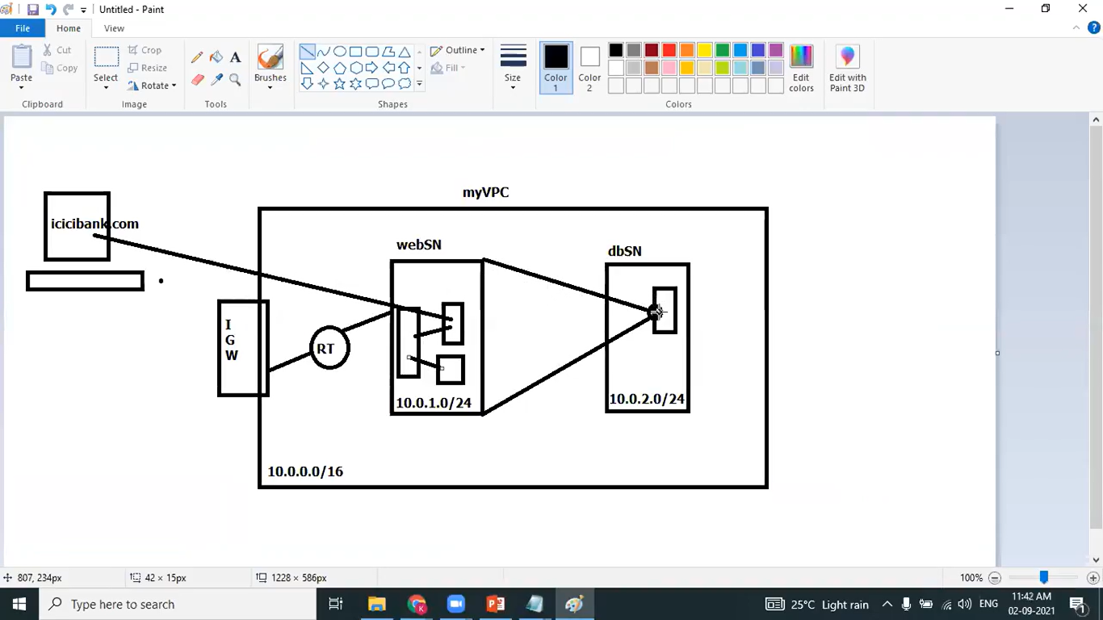

Fig: the an overview of project

Terraform code:

# Creating VPC

resource "aws_vpc" "demovpc" {

cidr_block = "${var.vpc_cidr}"

tags = {

Name = "Demo VPC"

}

}

# Creating 1st web subnet

resource "aws_subnet" "public-subnet-1" {

vpc_id = "${aws_vpc.demovpc.id}"

cidr_block = "${var.subnet_cidr}"

map_public_ip_on_launch = true

availability_zone = "us-east-1a"

tags = {

Name = "Web Subnet 1"

}

}

# Creating 2nd web subnet

resource "aws_subnet" "public-subnet-2" {

vpc_id = "${aws_vpc.demovpc.id}"

cidr_block = "${var.subnet1_cidr}"

map_public_ip_on_launch = true

availability_zone = "us-east-1b"

tags = {

Name = "Web Subnet 2"

}

}

# Creating 1st application subnet

resource "aws_subnet" "application-subnet-1" {

vpc_id = "${aws_vpc.demovpc.id}"

cidr_block = "${var.subnet2_cidr}"

map_public_ip_on_launch = false

availability_zone = "us-east-1a"

tags = {

Name = "Application Subnet 1"

}

}

# Creating 2nd application subnet

resource "aws_subnet" "application-subnet-2" {

vpc_id = "${aws_vpc.demovpc.id}"

cidr_block = "${var.subnet3_cidr}"

map_public_ip_on_launch = false

availability_zone = "us-east-1b"

tags = {

Name = "Application Subnet 2"

}

}

# Create Database Private Subnet

resource "aws_subnet" "database-subnet-1" {

vpc_id = "${aws_vpc.demovpc.id}"

cidr_block = "${var.subnet4_cidr}"

availability_zone = "us-east-1a"

tags = {

Name = "Database Subnet 1"

}

}

# Create Database Private Subnet

resource "aws_subnet" "database-subnet-2" {

vpc_id = "${aws_vpc.demovpc.id}"

cidr_block = "${var.subnet5_cidr}"

availability_zone = "us-east-1b"

tags = {

Name = "Database Subnet 2"

}

}

# Creating Internet Gateway

resource "aws_internet_gateway" "demogateway" {

vpc_id = "${aws_vpc.demovpc.id}"

}

# Creating Route Table

resource "aws_route_table" "route" {

vpc_id = "${aws_vpc.demovpc.id}"

route {

cidr_block = "0.0.0.0/0"

gateway_id = "${aws_internet_gateway.demogateway.id}"

}

tags = {

Name = "Route to internet"

}

}

# Associating Route Table

resource "aws_route_table_association" "rt1" {

subnet_id = "${aws_subnet.public-subnet-1.id}"

route_table_id = "${aws_route_table.route.id}"

}

# Associating Route Table

resource "aws_route_table_association" "rt2" {

subnet_id = "${aws_subnet.public-subnet-2.id}"

route_table_id = "${aws_route_table.route.id}"

}

# Creating Security Group

resource "aws_security_group" "demosg" {

vpc_id = "${aws_vpc.demovpc.id}"

# Inbound Rules

# HTTP access from anywhere

ingress {

from_port = 80

to_port = 80

protocol = "tcp"

cidr_blocks = ["0.0.0.0/0"]

}

# HTTPS access from anywhere

ingress {

from_port = 443

to_port = 443

protocol = "tcp"

cidr_blocks = ["0.0.0.0/0"]

}

# SSH access from anywhere

ingress {

from_port = 22

to_port = 22

protocol = "tcp"

cidr_blocks = ["0.0.0.0/0"]

}

# Outbound Rules

# Internet access to anywhere

egress {

from_port = 0

to_port = 0

protocol = "-1"

cidr_blocks = ["0.0.0.0/0"]

}

tags = {

Name = "Web SG"

}

}

# Create Database Security Group

resource "aws_security_group" "database-sg" {

name = "Database SG"

description = "Allow inbound traffic from application layer"

vpc_id = aws_vpc.demovpc.id

ingress {

description = "Allow traffic from application layer"

from_port = 3306

to_port = 3306

protocol = "tcp"

security_groups = [aws_security_group.demosg.id]

}

egress {

from_port = 32768

to_port = 65535

protocol = "tcp"

cidr_blocks = ["0.0.0.0/0"]

}

tags = {

Name = "Database SG"

}

}

# Creating 1st EC2 instance in Public Subnet

resource "aws_instance" "demoinstance" {

ami = "ami-087c17d1fe0178315"

instance_type = "t2.micro"

vpc_security_group_ids = ["${aws_security_group.demosg.id}"]

subnet_id = "${aws_subnet.public-subnet-1.id}"

associate_public_ip_address = true

user_data = "${file("data.sh")}"

tags = {

Name = "My Public Instance"

}

}

# Creating 2nd EC2 instance in Public Subnet

resource "aws_instance" "demoinstance1" {

ami = "ami-087c17d1fe0178315"

instance_type = "t2.micro"

vpc_security_group_ids = ["${aws_security_group.demosg.id}"]

subnet_id = "${aws_subnet.public-subnet-2.id}"

associate_public_ip_address = true

user_data = "${file("data.sh")}"

tags = {

Name = "My Public Instance 2"

}

}

# Creating RDS Instance

resource "aws_db_subnet_group" "default" {

name = "main"

subnet_ids = [aws_subnet.database-subnet-1.id, aws_subnet.database-subnet-2.id]

tags = {

Name = "My-DB-subnet-group"

}

}

resource "aws_db_instance" "default" {

allocated_storage = 10

db_subnet_group_name = aws_db_subnet_group.default.id

engine = "mysql"

engine_version = "8.0.32"

instance_class = "db.t2.micro"

multi_az = true

db_name = "mydb"

username = "username"

password = "password"

skip_final_snapshot = true

vpc_security_group_ids = [aws_security_group.database-sg.id]

}

# Creating External LoadBalancer

resource "aws_lb" "external-alb" {

name = "External-LB-1"

internal = false

load_balancer_type = "application"

security_groups = [aws_security_group.demosg.id]

subnets = [aws_subnet.public-subnet-1.id, aws_subnet.public-subnet-2.id]

}

resource "aws_lb_target_group" "target-elb" {

name = "ALB-TG"

port = 80

protocol = "HTTP"

vpc_id = aws_vpc.demovpc.id

}

resource "aws_lb_target_group_attachment" "attachment-1" {

target_group_arn = aws_lb_target_group.target-elb.arn

target_id = aws_instance.demoinstance.id

port = 80

depends_on = [

aws_instance.demoinstance,

]

}

resource "aws_lb_target_group_attachment" "attachment-2" {

target_group_arn = aws_lb_target_group.target-elb.arn

target_id = aws_instance.demoinstance1.id

port = 80

depends_on = [

aws_instance.demoinstance1,

]

}

resource "aws_lb_listener" "external-elb-listener" {

load_balancer_arn = aws_lb.external-alb.arn

port = "80"

protocol = "HTTP"

default_action {

type = "forward"

target_group_arn = aws_lb_target_group.target-elb.arn

}

}

Terraform output is given below: the load distributed across the two servers.

Server1 ip: 10-0-2-111.

Server2 ip: 10-0-1-44.

